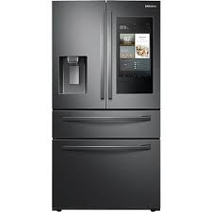

Samsung 625L

* French Door Fridge
* Gross Volumes Quoted
* Color Black
* Dispenser Ice And Water
* **Rs.79,000**